CHAIRMAN/SECRETARY NEEDS TO READ THIS OUT!
Derbyshire YFC Weekly Update!

Bonfire Events:
Tuesday 5th – Ashbourne YFC @ Darley Moor Airfield, DE6 2ET
Tuesday 5th – North West Region @ Flagg Hall Farm SK17 9QW
Wednesday 6th – Derby YFC @ Elms Farm, Thurvaston, DE6 5BL
Friday 8th – Pleasley YFC @ Smallacres Farm, North Wingfield, S42 5NR
For those holding bonfire events some guidance notes are attached.

A meeting of the Finance and Management committee will take place on Thursday 7th November at Matlock Meadows a copy of the agenda is attached.

The agenda for the County AGM is attached if any club would like to put forward an amendment to any of the motions it must be received in county office by Thursday 7th November

NFYFC is hosting business and tenancy training with @SavillsRuralUK at locations around the country. First event is at Mount Cook Adventure Centre in Derbyshire on Friday 8th November from 3.30pm and there will be refreshments. The link to book on is https://www.eventbrite.co.uk/e/nfyfcsavills-business-and-tenancy-training-for-yfcs-derbyshire-tickets-65097789240

The Ten-Pin Bowling competition is on Sunday 24th November at the Genesis Centre, Alfreton starting at 7pm. A team of four, two male and two female of which at least two members must be aged 21 and under on 1st September 2019. The closing date for entries is Friday 8th November and the entry form is attached.

Sports competition results: Kwik Cricket 1st Ashover, 2nd Buxton, 3rd Pleasley, 4th Belper/Ashbourne; Netball 1st Derby, 2nd Belper, 3rd Hope Valley/Bakewell 4th Ashover, 5th Buxton, 6th Pleasley; Football 1st Buxton, 2nd Hope Valley, 3rd Derby, 4th Belper, 5th Ashbourne, 6th Ashover and 7th Pleasley

Herefordshire County Federation of Young Farmers’ Clubs are looking for 14 YFC Clubs across the country interested in doing a Club Exchange Weekend on the 25th – 27th September 2020, full details at http://c1924912.cdn.cloudfiles.rackspacecloud.com/image-23330.jpg

Future Dates!
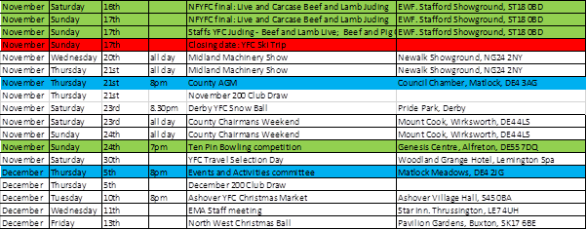

Jane Smith
County Administrator
Derbyshire Federation of Young Farmers’ Clubs
www.derbyshireyfc.org.uk

Office Hours:
Monday and Thursday 10.30 am – 4.00 pm
Friday 2.00 pm – 4.00 pm
Thursday evening 8.00pm – 10.00 pm

