CHAIRMAN/SECRETARY NEED TO READ THIS OUT!
Derbyshire YFC Weekly Update!

Ashover Show - Wednesday 14th August
Ashover Show After Show Do Saturday 17th August on the showground. https://www.facebook.com/events/395865151201647/permalink/484399872348174/
Ashbourne Show and After Show Do – Saturday 17th August at Osmaston Polo Ground

Has anyone taken the tables out of the publicity trailor?

All farmers and food producers are being encouraged to get involved in sharing positive messages about food and farming in the build up to British Food Fortnight from 21 September to 6 October 2019.
All you need to do is post images about your work on social media using the hashtag #BritishFoodisGreat along with who you are and what you produce. Send the image to the British Food Fortnight team and they will include it as part of their collection and add to the website for others to download. So for example your post text could include: I am [NAME], I am a [JOB], producing [PRODUCT] #BritishFoodisGreat.
If you see the British Food is Great images on social media sites, share them online and where possible why not print them off and ask to display them in your offices, local cafés or restaurants?
The team are also keen to make farmers and food producers the heroes and are keen to see short videos that include the following:
- Who you are
- What you produce/farm
- #BritishFoodisGreat – end with this hashtag – either by speaking the hashtag, or by writing it on paper – make a sign, or purchase one from the website.
Post your video on social media channels and send to the British Food is Great team – don’t forget to include #BritishFoodisGreat and @LoveBritishFood – when you post

NFYFC has two scholarship places available for YFC members who can represent the Federation at the Oxford Farming Conference from 7-9 January 2020.

Other Organisations
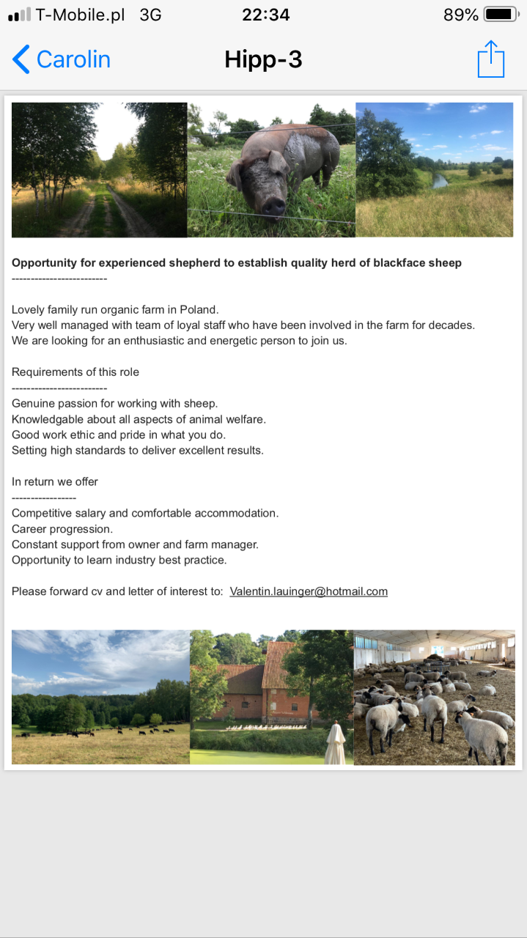

Future YFC
Hope Show - Monday 26th August
NFYFC finals Stockman and Young Stockman of the Year competitions on Saturday 1st/Sunday 2nd September
Events and Activities Committee meeting Thursday 5th September at Matlock Meadows
Club Officer Training event will be on Sunday 29th September at Mount Cook, Wirksworth,
The NFYFC final of the Cookery – Saturday 28th September, and Floral Art – Junior, Intermediate and Senior – Sunday, 29th September. All Competitions will be held at the Autumn Festival, Three Counties Showground, Malvern, Worcestershire

County Committee AGM’s Thursday 3rd October

County Dinner and Dance on Friday 11th October at Morley Hayes

Please note the Derbyshire YFC website is: http://www.derbyshireyfc.org.uk and the NFYFC website is: http://www.nfyfc.org.uk

Clubs
www.derbyshireyfc.org.uk
Fun, Learning and Achievement

Jane Smith
County Administrator
Derbyshire Federation of Young Farmers’ Clubs
www.derbyshireyfc.org.uk

Office Hours:
Monday and Thursday 10.30 am – 4.00 pm
Thursday 8.00 pm – 10.00 pm
Friday 2.00 pm – 4.00 pm

