CHAIRMAN/SECRETARY NEEDS TO READ THIS OUT!
Derbyshire YFC Weekly Update!

County Competitions Day is on Sunday 2nd February at Lady Manners school, Bakewell. The attached table shows the entries which have been received. Please check the empty boxes against your club name and either forward names or confirm that you will not be entering.

The book for the junior reading is ‘The Book Thief’ by Markus Zusak ISBN 978-0-55277-973-9. Three passages will be selected from the book which the competitors will read out on the day. The chairman of the team will be required to give a brief background of the book.

The draw and motions for the MACE debating competition are attached, this is not the order of competing

If you have not already done so please send the completed synopsis forms for both junior and senior member of the year and the job advert, CV and letter of application for the situation vacant competition as they need to be sent to the judges prior to the day.

We need to determine if it is worth booking a venue for the drama competition therefore the closing date for entries has been brought forward to Friday 31st January and the entry form is attached

British Wool have kindly agreed to subsidise Blue Seal Qualification training courses for NFYFC Members as they have for the past 2 years. Details of the courses are available on the attached flier. The closing date is the 30th March, 2020. Members competing in the sheep shearing competition at the County Rally must have a Blue Seal certificate!

If you have not already done so please will you forward a copy of your club programme to Emma Holmes emma.holmes93@gmail.com this is for the club efficiency competition.

Booking details for the Cleethorpes weekend were sent to club secretaries in November, the closing date for orders at the discounted rate is 31st January

Do you enjoy singing and are aged 8 to 14? You may be interested in advancing your vocal training and singing within a small young people's choir based at Baslow St. Anne's? 2020 rehearsals of Young Voices started on 14th January in Baslow St. Anne's Church. As well as rehearsing pieces to sing within key church services and other events locally we have a strong focus on developing vocal technique and voice production - so it's ideal for any children who would like singing lessons - and it is fully funded by the church. If you're interested, please get in touch with Claire De la Haye on 07515 287222 or simply come along on a Tuesday at 5.30pm (Please note that we use the vestry door for rehearsals).

Forthcoming Dates:
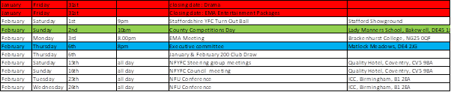

Jane Smith
County Administrator
Derbyshire Federation of Young Farmers’ Clubs
www.derbyshireyfc.org.uk

Office Hours:
Monday and Thursday 10.30 am – 4.00 pm
Friday 2.00 pm – 4.00 pm
Thursday evening 8.00pm – 10.00 pm

