CHAIRMAN/SECRETARY NEEDS TO READ THIS OUT!
Derbyshire YFC Weekly Update!

A meeting of the Executive Committee Meeting will be held on Thursday 10th October at Matlock Meadows. A copy of the agenda is attached. We will also be approving the 2016/2017 accounts

The County Dinner and Dance is on Friday 11th October 7.30 for 8.00pm at Morley Hayes DE7 6DG. Will all clubs please provide two raffle prizes with a minimum value of £10 each. The Members Member award will be presented along with the trophies for Club Chairman, Secretary and Treasurer of the year and the new Club of the Year trophy.

Staffs YFC Autumn Ball is on Saturday 19th October at Pirelli at Burton Albion. Tickets are on sale via Ticketsource.co.uk. Dress code: Black tie / evening dress. Strictly NO under 18's - current membership cards required plus other ID.

The pre-Rally Beef and Sheep stock judging will be held on Sunday 20th October at Sitch Farm, Wormhill, SK17 8SH by kind permission of the Mosley family starting at 10am, please will members ‘car share’ to limit the number of cars. The carcase judging will be on Wednesday 23rd October at Redferns abattoir, Harpur Hill, Buxton SK17 9HT, juniors and intermediates at 6.30pm and seniors at 8.00pm. The live pig stock judging will be held later in the year. The closing date for entries is Thursday 10th October, the same person must judge the live and carcase sections and the entry form is attached.

The date for the County Rally has now been confirmed for Saturday 23rd May at Earl Sterndale by kind permission of the Hodgkinson family

Minutes of the County Committee AGMs are attached

The sports competitions are on Sunday 3rd November at Anthony Gell School, Wirksworth, full details are in the County Competitions Rule Book and the closing date for entries is Friday 18th October. The membership renewal/application form must have been received in county office by this date for all members who are competing. Entry forms are attanched

A reminder that the deadline for applications to MH:2K: youth-led mental health project is Monday 14th October. It is a fantastic chance for young people to take action within their communities, improve their leadership skills, and make a real impact to mental health services across Derbyshire. Attached are the necessary documents including the flyer, a description of the role and an application form.

Future Dates!
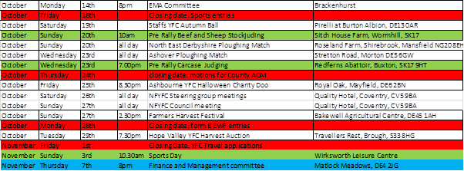

Jane Smith
County Administrator

Derbyshire Federation of Young Farmers’ Clubs
www.derbyshireyfc.org.uk

Office Hours:
Monday and Thursday 10.30 am – 4.00 pm
Friday 2.00 pm – 4.00 pm
Thursday evening 8.00pm – 10.00 pm

