CHAIRMAN/ SECRETARY NEED TO READ THIS OUT!
Derbyshire YFC Weekly Update!
Live and Carcase Judging - The Pig and Carcase Judging will be held on Wednesday 17th October - 7.00pm at Haslin Abattoir, Harpur Hill, Buxton, SK17 9HT, BKPO F Redfern & Sons. The Beef and Lamb Judging will be held on Sunday 28th October – 10am at Hazelwood Hall Farm, Belper, DE56 4AW, BKPO the Heath Family. The rules are attached.
Sports Day Entries – Entry forms attached, closing date for entries Friday 19th October. All those competing must have their membership form in county office by this date
County Dinner and Dance on Saturday 20th October at the Palace Hotel, Buxton at 7.30 for 8.0pm. Please will Clubs, Vice Presidents and Field Officers provide a raffle prize.
NFYFC Council Weekend on Saturday 20th/Sunday 21st October
Executive Committee - Meeting minutes will be sent next week
YFC Travel – information booklet attached for all the trips available
Other Organisations
Love in the Countryside - Boundless Productions are making a second series of the BBC Two show Love in The Countryside and looking for rural singles who are looking for love but find it difficult to meet potential partners. Further details on the attached flyer.
YFC Forthcoming Dates !
North East Derbyshire Ploughing Match on Wednesday 24th October at Span Carr
Bakewell YFC Halloween Party on Friday 26th October at Biggin Village Hall. £5 on the door, Fancy Dress Optional, 16+, ID required - Wrist Band Policy in operation. All 16 and 17 year olds must have a membership card and a parental consent form on the night.
Staffs YFC Spooktacular Ball on Saturday 27th October - Pirelli at Burton Albion. Tickets on sale via Ticketsource.co.uk. Dress code: Black tie / evening dress. Strictly NO under 18's - current membership cards required plus other ID.
Farmers Harvest Festival on Sunday 28th October 2.30pm at the Agricultural Business Centre, Bakewell
YFC Travel - members are now able to apply for the 2019 YFC Travel trips. This year there are new YFC Travel application forms. Please ensure that all YFC members wishing to apply for a trip use the new applications forms, which should all be signed by the County Office prior to being sent to NFYFC. Further trip details for the YFC Travel trips can be found on the NFYFC website: http://www.nfyfc.org.uk/travelwithYFC/yfctravel
Enderby YFC annual Halloween doo on Friday 2nd November
Sports Day on Sunday 4th November –Wirksworth Leisure Centre
Derby YFC Snow Ball Saturday 10th November – The Bentley Brook Inn
Farmers Weekly Ag Careers Live is a free event held on the Thursday 15th November from 10:00 – 15:00 at Villa Park, Birmingham
North West Christmas Ball Friday 14th December Pavilion Gardens, Buxton SK17 6BE
#YFCSki19 – Saturday 5th–Saturday 12th January 2019, Belle Plagne, France
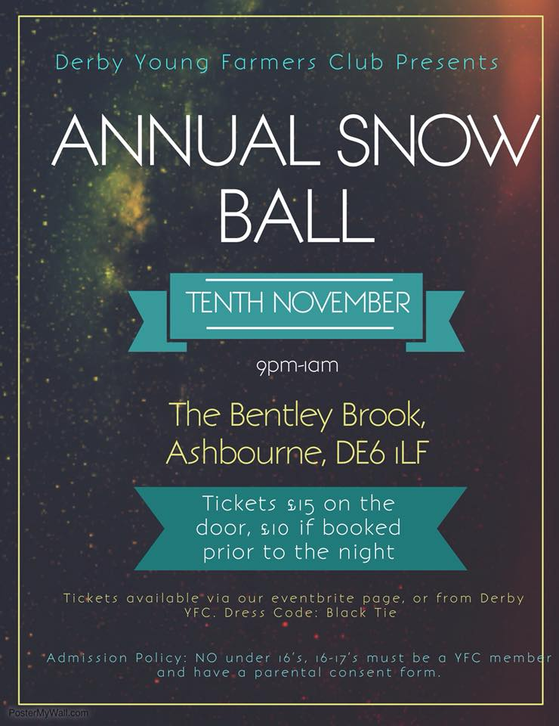
Please note the Derbyshire YFC website is: http://www.derbyshireyfc.org.uk and the NFYFC website is: http://www.nfyfc.org.uk

Jane Smith
County Administrator
Derbyshire Federation of Young Farmers’ Clubs
www.derbyshireyfc.org.uk

Office Hours:
Monday and Thursday 10.30 am – 4.30 pm
Thursday 8.00 pm – 10.00 pm
Friday 2.00 pm – 4.00 pm

LITC Flyer - Rural.jpg

