CHAIRMAN/ SECRETARY NEED TO READ THIS OUT!
Derbyshire YFC Weekly Update!
Harvest Auction – Hope Valley YFC have their annual Harvest Auction on Tuesday 30th October at the Travellers Rest, Brough, S33 8HG starting at 7.30pm. All proceeds to the Children’s Hospital Charities and club funds.
YFC Travel 2019 closing date for applications is Friday 2nd November, trip details can be found on the NFYFC website: http://www.nfyfc.org.uk/travelwithYFC/yfctravel
Finance and Management Committee meeting on Thursday 1st November. A copy of the agenda is attached. All membership renewal/application forms have now been processed and the cards will be available for collection from the meeting
Pleasley YFC Bonfire on Friday 2nd November at Dave Clayton’s farm in North Wingfield from 7pm
Halloween doo - Enderby YFC’s annual event on Friday 2nd November details attached
Sports Day on Sunday 4th November – Anthony Gell School/Wirksworth Leisure Centre, DE4 4JG teams must check in at 9.30am for a prompt start at 10am. Membership cards will be checked. If any further teams would like to enter we will allow members to compete in more than one competition and it is also permitted for members from different clubs to make up a team if they don’t have enough members of their own to make up a team
Live and Carcase Stockjudging Results: Beef – Senior 1st Andrew Gregory-Campeau, Buxton YFC, 2nd Sam Woolley, Pleasley YFC, 3rd George Hammersley, Derby YFC; Intermediate 1st James Hodgkinson, Hope Valley YFC, 2nd Thomas Wildgoose, Pleasley YFC, 3rd Catherine Bunting, Bakewell YFC; Junior 1st Molly Astley, Hope Valley YFC, 2nd George Walker, Bakewell YFC, 3rd Joshua Wildgoose, Pleasley YFC. Sheep – Senior 1st Rosie Deakin, Pleasley YFC, 2nd Vicky Beal, Hope Valley YFC, 3rd Matthew Burnhope, Derby YFC; Intermediate 1st Martha Bland, Hope Valley YFC, 2nd Sam Botham, Pleasley YFC, 3rd James Bunting, Bakewell YFC; Junior 1st Ben Gratton, Buxton YFC, 2nd Jon Oldfield, Bakewell YFC, Jenson Bowden, Hope Valley YFC. Pig – Senior 1st Ruth Rastrick, Ashover YFC, 2nd John Armitage, Belper YFC, 3rd Alice Morley, Hope Valley YFC; Intermediate 1st = Matthew Clark, Hope Valley YFC & Sam Blagg, Pleasley YFC, 3rd Ben Wildgoose, Ashbourne YFC; Junior 1st Zara Bowden, Hope Valley YFC, 2nd Max Harrop, Bakewell YFC, 3rd Amy Brittain-Cartlidge, Buxton YFC. Please speak to your members and send feedback on holding the competition in autumn.
Live and Carcase Judging @ English Winter Fair - Members who qualified for the Live and Carcase Judging: Beef Derbyshire A – Andrew G-C and James Hodgkinson, Derbyshire B – Sam Woolley and Thomas Wildgoose. Pig Derbyshire A – Ruth Rastrick and Matthew Clark, Derbyshire B – John Armitage and Sam Blagg. The live judging will take place on Saturday 17th and the carcase on Sunday 18th November. Members who qualified for the Staffs YFC competitions on Sunday 18th November – Live Lamb (A) Suzie Cooper and Sam Botham, (B) Matthew Burnhope and Robert Webster. Live Beef (A) Tom Weston and Jessica Langton, (B) Lucy Hollingworth and Catherine Bunting. Lamb Carcase (A) Rosie Deakin and Martha Bland, (B) Vicky Beal and Jake Williams. Pork Carcase (A) Alice Morley and Ben Wildgoose, (B) Philip Lawton and Isobelle Rodgers. Please check all these members are able to compete and let Jane know asap. Details are in the County Competitions Rule Book or contact county office for a copy of the rules to be sent.
County AGM Agenda – Will the members who are proposing the President/Vice President at the County AGM please forward a few words about them to include on the Agenda so members know a little about the person they are voting for.
Barlow YFC Bonfire on Tuesday 6th November at The Hawthorns, Lydgate, Holmesfield, S18 7WB
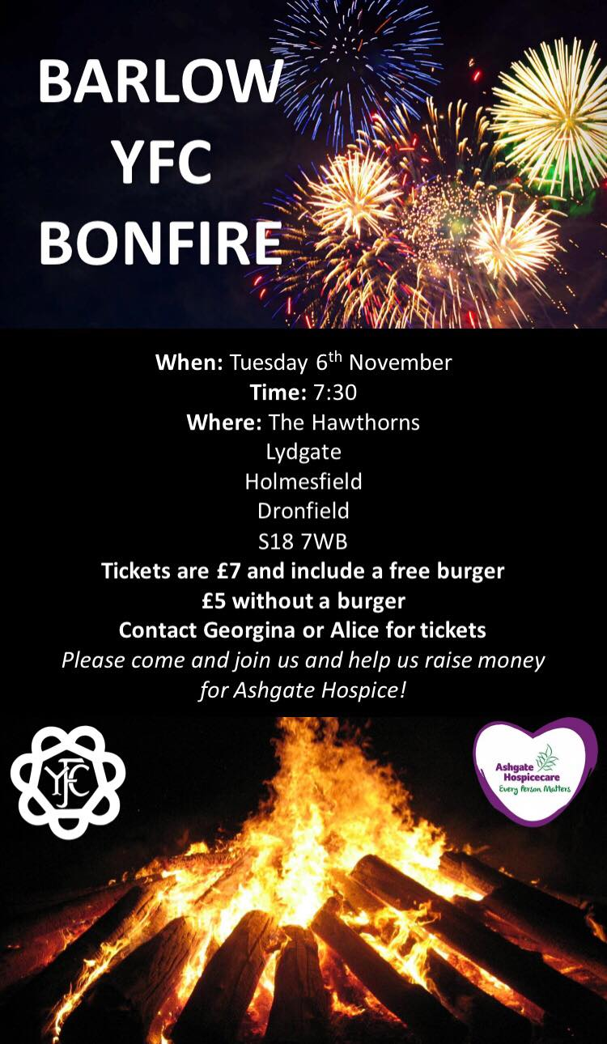
Ashbourne YFC Bonfire – Beat N Trak DJ Landrover is at Darley Moor Airfield. We're going to be giving Ashbourne Young Farmers Club a hand at their bonfire and fireworks night on Tuesday 6th November. Requests always welcome, so come and catch up with us!
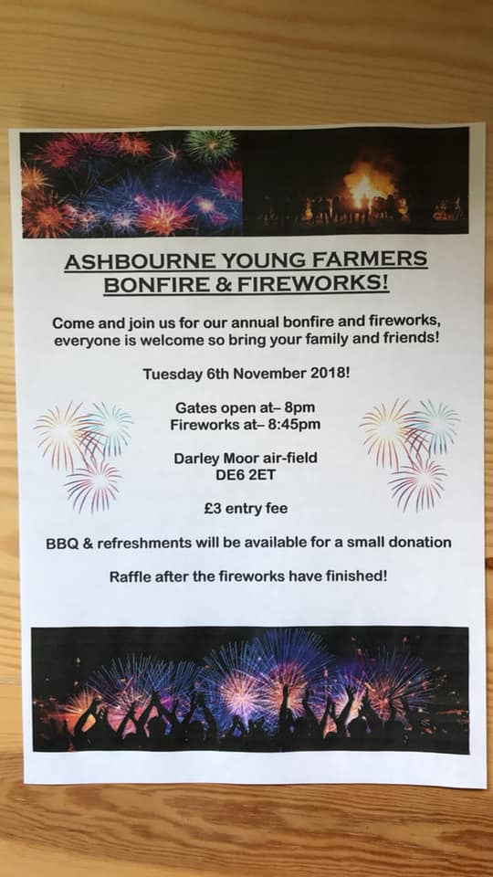
Other Organisations
TBAS Newsletter for October attached
YFC Forthcoming Dates !
Derby YFC Snow Ball Saturday 10th November – The Bentley Brook Inn
Farmers Weekly Ag Careers Live is a free event held on the Thursday 15th November from 10:00 – 15:00 at Villa Park, Birmingham
County AGM – will take place on Thursday 22nd November in the Council Chamber, County Hall, Matlock starting at 8pm.
North West Christmas Ball Friday 14th December Pavilion Gardens, Buxton SK17 6BE
#YFCSki19 – Saturday 5th–Saturday 12th January 2019, Belle Plagne, France
EMA Train the Trainer course is being held on 9th and 10th of February 2019 at the Mount Cook Adventure in Derbyshire.
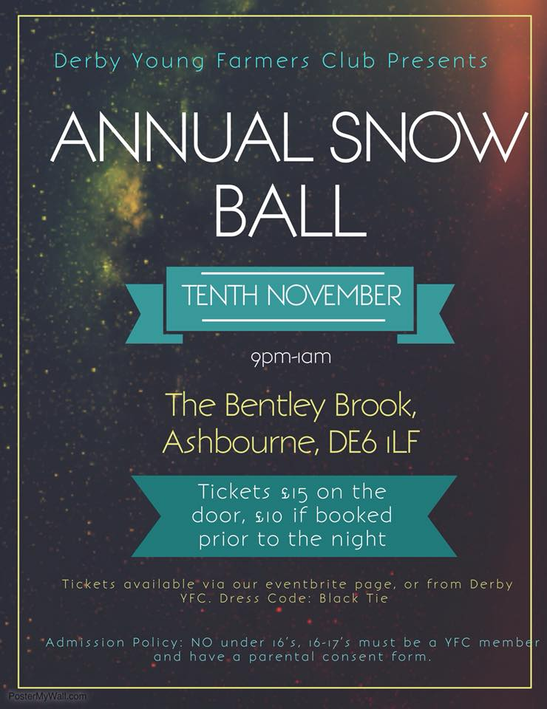

Please note the Derbyshire YFC website is: http://www.derbyshireyfc.org.uk and the NFYFC website is: http://www.nfyfc.org.uk

Jane Smith
County Administrator
Derbyshire Federation of Young Farmers’ Clubs
www.derbyshireyfc.org.uk

Office Hours:
Monday and Thursday 10.30 am – 4.30 pm
Thursday 8.00 pm – 10.00 pm
Friday 2.00 pm – 4.00 pm

YFC Halloween poster with FB like.png
