CHAIRMAN/SECRETARY NEED TO READ THIS OUT!
Derbyshire YFC Weekly Update!
EMA Eliminators: for the Cube exhibit, Mens and Ladies Tug of War and EMA Stock judging at Lincolnshire Show, LN2 2NA on Thursday 20th June. The very best of luck to the teams and individuals who are taking part!

NFYFC Council Weekend – on Saturday 22nd and Sunday 23rd June at the Quality Hotel, Coventry, CV5 9BA

Big Summer Sesh on Saturday 22nd June at Stanedge Grange, Newhaven SK17 0DT. Get your tickets here!
https://www.eventbrite.com/e/big-summer-seshderbyshire-yfc-tickets-59854348969
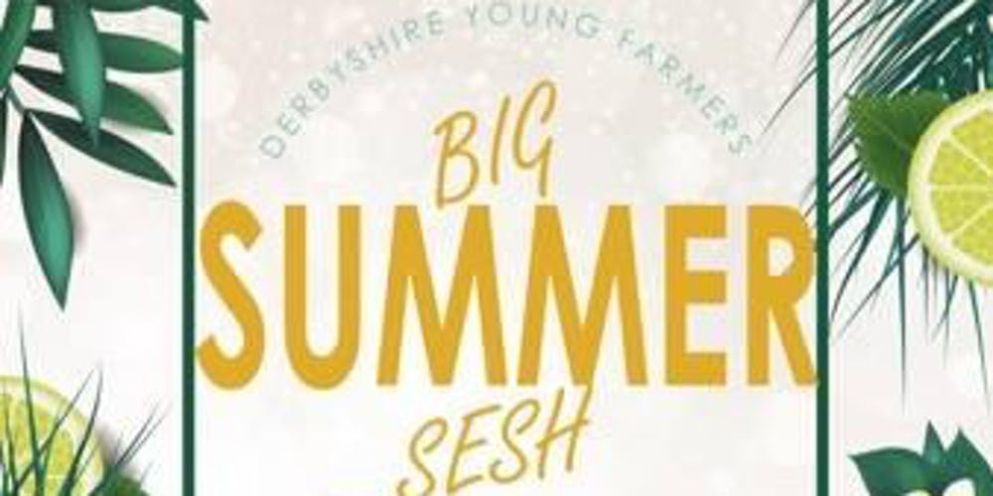 | Big Summer SeshDerbyshire YFC - eventbrite.com  www.eventbrite.com  Eventbrite - Derbyshire Young Farmers presents Big Summer SeshDerbyshire YFC - Saturday, June 22, 2019 | Sunday, June 23, 2019 at Stanedge Grange, Newhaven, England. Find event and ticket information.

16/17 year olds will need to purchase a ticket beforehand and at the same time hand in a completed parental consent form therefore they cannot buy a ticket online. There will be no admission to 16/17’s on the door and they must be a YFC member to purchase a ticket. Over 18’s will be given a wristband at the door and they will need ID photo ID (drivers license or passport). Only those wearing a wristband will be served at the bar. Because of the licensing laws and insurance NO UNDER 16s will be allowed to buy a ticket or attend, and if they do get a ticket they WILL NOT be allowed in.
Other Organisations
Derbyshire County Show on Sunday 23rd June at the showground, Borrowash Road, Elvaston
Farm to Plate - celebrating 200 years of Bakewell Agricultural and Horticultural Society on Sunday 30th June at the showground, Bakewell
Future YFC
EMA eliminator: for fence erecting, Stockman of the year and junior Tug of War at Blaston Show, Slawston, LE16 7UF on Sunday 30th June
Finance and Management committee meeting on Thursday 4th July at Matlock Meadows, DE4 2JG
Please note the Derbyshire YFC website is: http://www.derbyshireyfc.org.uk and the NFYFC website is: http://www.nfyfc.org.uk
NFYFC-National Federation of Young Farmers' Clubs
www.nfyfc.org.uk
WHAT WE DO. We are one of the largest rural youth organisations in the UK dedicated to young people who have a love for agriculture and rural life.

Clubs
www.derbyshireyfc.org.uk
Fun, Learning and Achievement

Jane Smith
County Administrator
Derbyshire Federation of Young Farmers’ Clubs
www.derbyshireyfc.org.uk
Clubs
www.derbyshireyfc.org.uk
Fun, Learning and Achievement

Office Hours:
Monday and Thursday 10.30 am – 4.00 pm
Thursday 8.00 pm – 10.00 pm
Friday 2.00 pm – 4.00 pm

